News & Events (update, under “Previous Events”)

Chef’s Challenge  
November, 2010

Thank you to those who have sponsored Emily towards her fund raising goal in support of Mount Sinai Hospital’s Chef’s Challenge event in November 2010. Emily raised over $3,000 for research & education of breast & ovarian cancer.

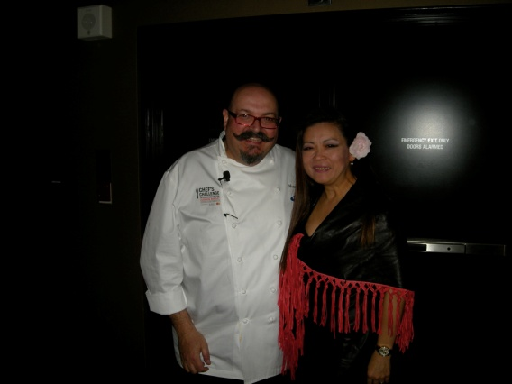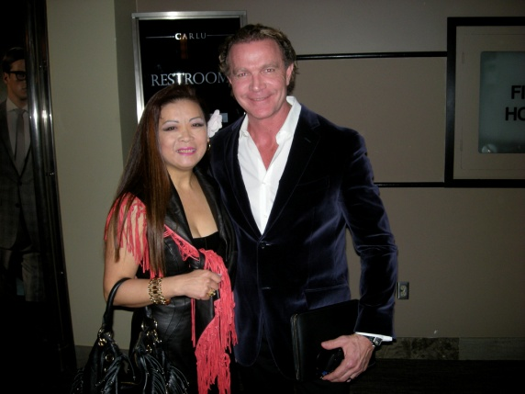

Massimo Capra Mark McEwan

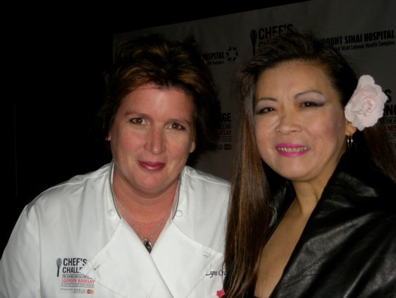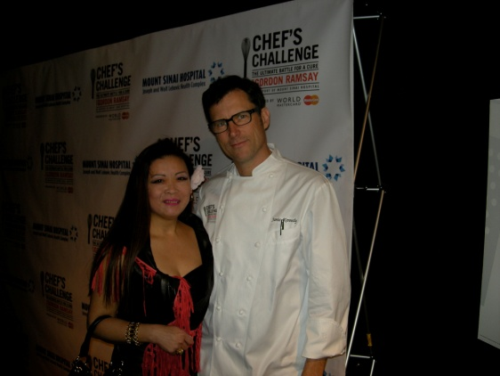

Lynn Crawford Jamie Kennedy

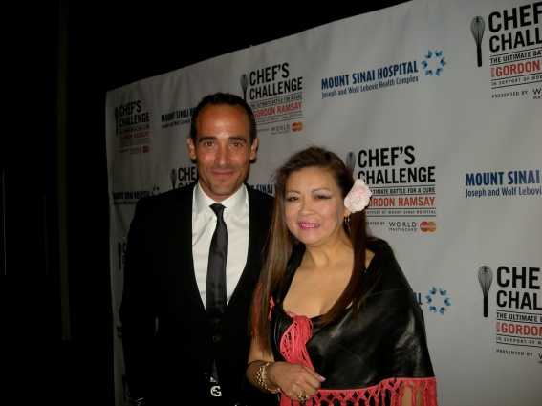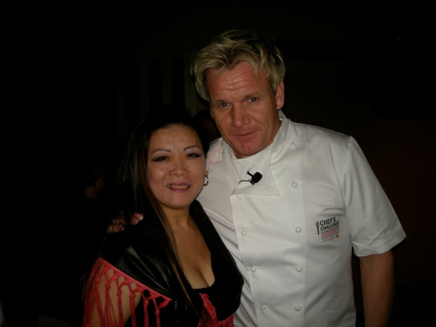

David Rocco Gordon Ramsay

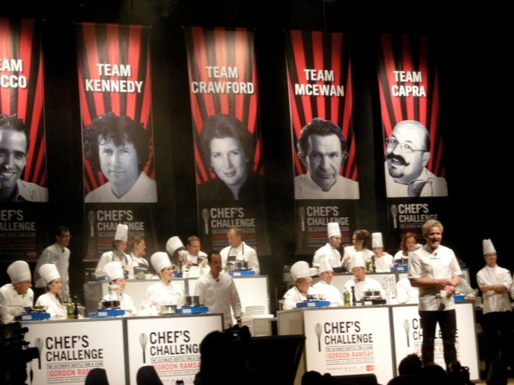

**Harvest Celebration Tea Party**

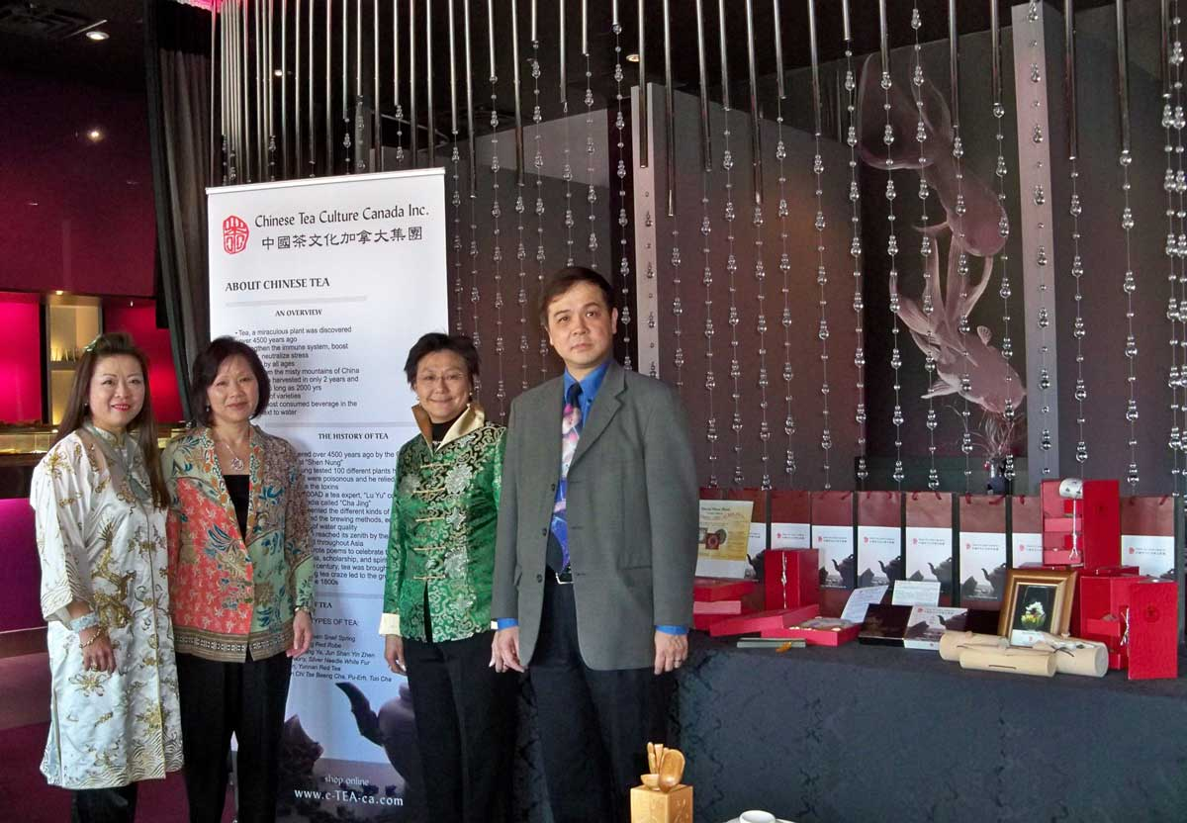 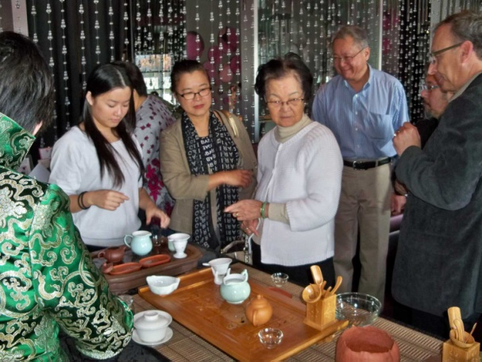

Tea Party at Dozo Sushi and Sake Bar

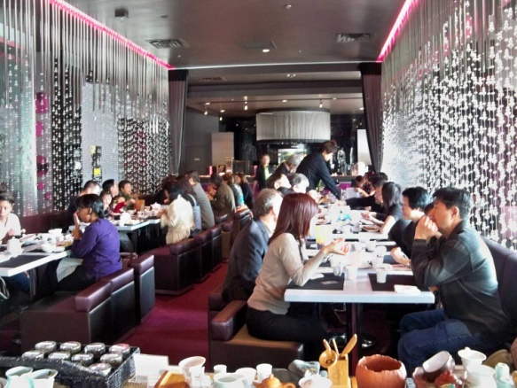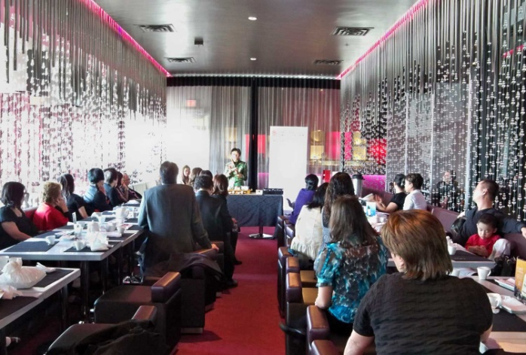

Tea Party Guests Tea Presentation by Tea Master Mrs Connie Fong

Culture & Education (update)

**2011 Tea Class**

**Learn how to perform an authentic Chinese Tea Ceremony  
First come… first served.\***

Chinese Tea Culture Canada Inc. invites you into the fascinating world of Chinese teas with its rich history & flavours.

**A series of 4 tea classes**

A series of 4 tea classes   
Thursday evenings, 6:30pm – 8:00pm

A comprehensive course designed to offer students a thorough understanding of Chinese tea, its history, tea production & culture, how to recognize and appreciate premium whole leaf teas, as well as the health benefits.

$159.00/person or $279.00/person (includes special accessory package)

For details, please see:

Tea Class Details (PDF)  
Attendee Registration (PDF)   
We can also be reached directly at 905-470-1493

*Chinese Tea Culture Canada Inc. reserves the right to cancel any school 10 days prior to the scheduled date if class participation is less than 5 students*.

**One day Seminar**

Sunday 2:30pm – 4:30pm

Introduction to Tea Appreciation

How to recognize, prepare and enjoy premium whole leaf teas. Includes tasting of 3 teas  
$20 per person  
Members at $10 per person (member may bring a maximum of 4 guests at $10.00 per person)

for more information, please call us: 905-470-1493

*Chinese Tea Culture Canada Inc. reserves the right to cancel any school 10 days prior to the scheduled date if class participation is less than 5 students.*

Tea Shop

Change “Holiday Specials” to “New Year’s Special”